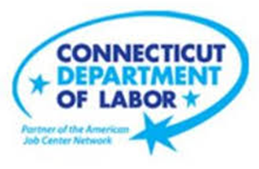

**NEW WEEKLY JOB POSTINGS FROM   
HELP WANTED ONLINE  
Office of Research**

**Week Ending January 14th, 2023: Weekly New Ads Spring Up to Highest Level Since June 2022.**WETHERSFIELD, January 20th, 2022 – During the week ending January 14th, there were 9,128 new postings, up 3,137 or +52% over the week. This 3,137 over-the-week increase follows a 2,265 increase the week before and results in the largest weekly total new ad level since June 2022. The graph below illustrates the pronounced two-week increase that followed the sharp late-December drop that occurred around the holiday season. Every industry had over-the-week increases of 23% or more. The three largest industries increases accounted for 43% of the overall increase, Health Care & Social Assistance (+674 new ads or +41%), Retail Trade (+345 new ads or +65%), and Manufacturing (+344 new ads or +77%). The largest employer increases among those three industries respectively were Yale-New Haven Health System (+201 new ads), Walmart/Sams (+83 new ads), and Lockheed Martin Corporation (+32 new ads). The occupations with the largest over-the-week increase are Retail Salespersons (+127 new ads), Registered Nurses (+77 new ads), and Wholesale & Manufacturing Sales Representatives (+53 new ads).   
  
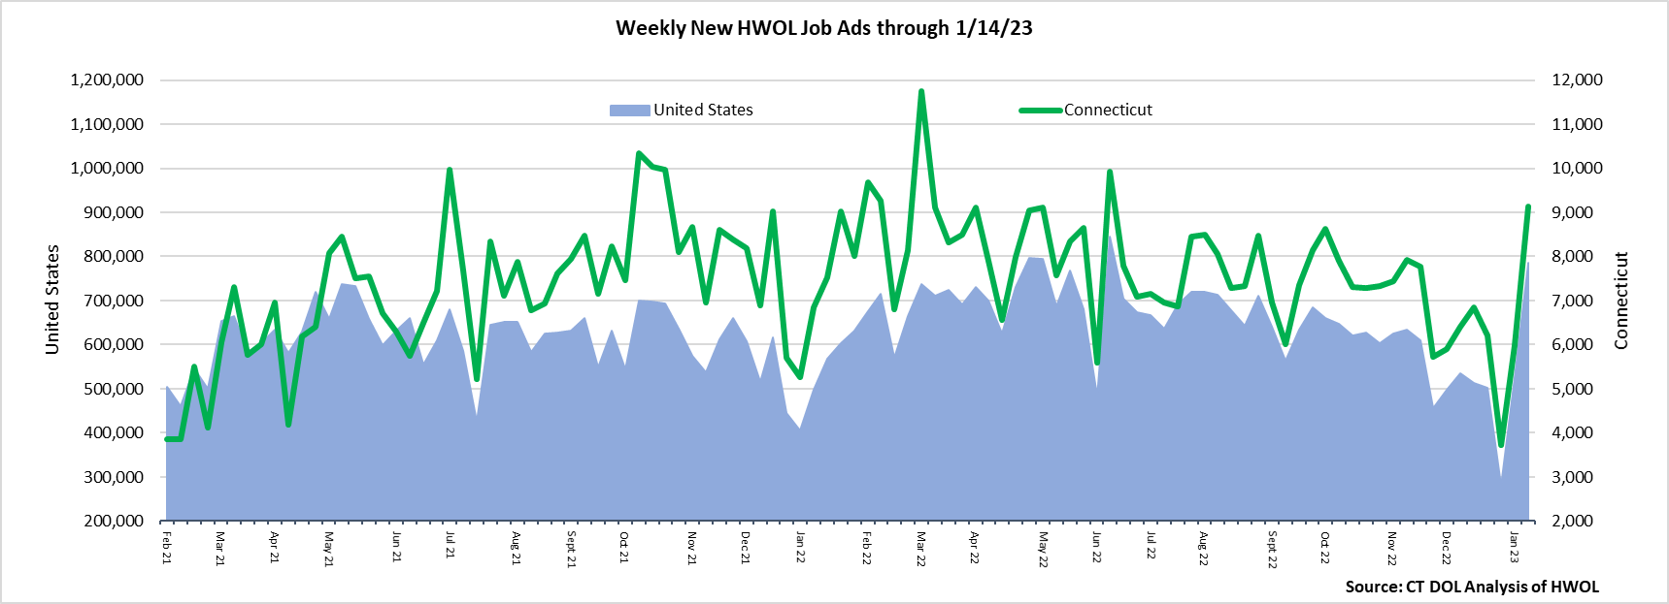  
**Industries** with the most new postings include Health Care & Social Assistance, Retail Trade, and Manufacturing.

**Occupations** with the most new postings include Registered Nurses, Retail Salespersons, and Supervisors of Retail Sales Workers.

**Employers** with the most new postings include Yale-New Haven Health System, Hartford Healthcare, and Child Guidance Center of Southern Connecticut.

**The three industries with the most new job postings were:**

* **Health Care & Social Assistance** (2,300 new postings, +41% over the week)
* **Retail Trade** (874 new postings, +65% over the week)
* **Manufacturing** (793 new postings, +77% over the week)

   
 During the week ending January 14th, 2023, the 52% new ad total increase is the net result of increases in all twenty-one industries shown in the above table. Fifteen industries had over-the-week gains of 50% or more, and seven were up 75% or more. The largest over-the-week increase occurred in Health Care & Social Assistance (+674 new ads) and the smallest increase occurred in Mining & Extraction (+2 new ads). Compared to four weeks ago, total ads are up 33% or +2,287 new ads, and every industry other than Health Care & Social Assistance (-4 new ads) was up over four weeks.   
  
 For more information on total job ads by industry for Connecticut and its labor market areas, see the monthly report available here: <https://www1.ctdol.state.ct.us/lmi/hwol.asp>

**New Job Postings by Occupation** 

**The occupations with the most new postings were:**

* Registered Nurses (550 new postings, +16% over the week)
* Retail Salespersons (311 new postings, +79% over the week)
* Supervisors of Retail Sales Workers (206 new postings, +34% over the week)

**Employers with the Most New Job Postings** Employers with the most new job postings during the week were mostly within Health Care & Social Assistance, Retail Trade, and Manufacturing. The 25 employers shown above account for 18 percent of all new ads. Twenty-one employers in the top 25 increased over the week and four decreased. Within the 25 largest employers, the largest increase occurred at Yale-New Haven Health System (+201 new ads) and the largest decrease occurred at Community Health Center, Inc. (-41 new ads).  
  
**What is HWOL?**The **Conference Board Help Wanted Online**® Data Series (HWOL) measures the number of new, first-time Online job postings and jobs reposted from the previous month for over 16,000 Internet job boards, corporate boards, and smaller job sites that serve niche markets and smaller geographic areas. To view more HWOL data, go to: <https://www1.ctdol.state.ct.us/lmi/hwol.asp>